**Version3**

1. Descriptive statistics

Actual_Donation_Amount Average: 9813.046623693597

Actual_Donation_Amount Variance: 3966231020.7807913

Actual_Donation_Amount Min: 0.0

Actual_Donation_Amount Max: 3431670.0

Actual_Donation_Amount Median: 1300.0

Campaign_Goal Average: 44797.3589085675

Campaign_Goal Variance: 23844896574.26401

Campaign_Goal Min: 100

Campaign_Goal Max: 5000000

Campaign_Goal Median: 5000.0

NPO_Tax_Deductibility Average: 0.9386069215845798

NPO_Tax_Deductibility Variance: 0.0576239683380983

NPO_Tax_Deductibility Min: 0

NPO_Tax_Deductibility Max: 1

NPO_Tax_Deductibility Median: 1.0

duration_day Average: 107.733400087615

duration_day Variance: 12088.133442917157

duration_day Min: -170

duration_day Max: 630

duration_day Median: 60.0

Campaign_Video Average: 0.40459352900682144

Campaign_Video Variance: 0.2408976052926278

Campaign_Video Min: 0

Campaign_Video Max: 1

Campaign_Video Median: 0.0

Msg_category Average: 1.1299831028224545

Msg_category Variance: 1.5541038297413958

Msg_category Min: 0

Msg_category Max: 3

Msg_category Median: 1.0

Campaign_Image_num Average: 2.8678265223105326

Campaign_Image_num Variance: 2.5242411674773044

Campaign_Image_num Min: 0

Campaign_Image_num Max: 5

Campaign_Image_num Median: 3.0

Num_desc_cam Average: 137.2523311846799

Num_desc_cam Variance: 4579.946342115488

Num_desc_cam Min: 1

Num_desc_cam Max: 309

Num_desc_cam Median: 143.0

Num_desc_NPO Average: 100.5663683584705

Num_desc_NPO Variance: 3181.0814422902467

Num_desc_NPO Min: 1

Num_desc_NPO Max: 179

Num_desc_NPO Median: 115.0

Org_causes Average: 3.019275298829714

Org_causes Variance: 2.3911423247988264

Org_causes Min: 0

Org_causes Max: 5

Org_causes Median: 4.0

Cam_causes Average: 3.4542211652794292

Cam_causes Variance: 0.9677240617311409

Cam_causes Min: 0

Cam_causes Max: 4

Cam_causes Median: 4.0

.

|  |  |  |  |  |
| --- | --- | --- | --- | --- |
|  | Mean | Variance | Max | Min |
| Actual_Donation_Amount | 9813 | 3966231020 | 3431670 |  |
| NPO_Tax_Deductibility |  |  |  |  |
| Campaign_Goal |  |  |  |  |
| Campaign_Video |  |  |  |  |
| Campaign_Image_num |  |  |  |  |
| duration_day |  |  |  |  |
| Msg1_category |  |  |  |  |
| Msg2_category |  |  |  |  |
| Msg3_category |  |  |  |  |
| Msg4_category |  |  |  |  |
| Msg5_category |  |  |  |  |
| Num_desc_cam |  |  |  |  |
| Num_desc_NPO |  |  |  |  |

I will make a table like this when you need

Table1 Descriptive statistics and correlation

Linear Regression Result

I checked the codes and found that there is no significant error in coding.

I searched some articles which they said that this phenomenon is reasonable because when we have many independent variables they will compete with each other. Even though some independent variables have positive relationship with dependent variable they may have negative regression relationship with dependent variable. I think this is one important character of liner regression. In order to test it I changed the model and compared the result as below.

Reference – *“When the path coefficient [regression coefficient] and the correlation between latent constructs do not have the same sing, the original relationship between the two has been suppressed. In general, there are three reasons for suppressor effects. The first is due to the fact that the original relationship between the two variables is so close to zero that the difference in the signs simply reflects random variation around zero. The second reason for suppression is that there are two or more variables que contain the same information and are therefore redundant. The switching of signs in this case is due to the order of the variables in the equation. In this situation the redundancy is artificially changing the signs, and one or more of the redundant variables must be eliminated.”*

<https://www.researchgate.net/post/What-does-it-indicating-If-there-is-positive-correlation-but-negative-regression-coefficient>

You can make a double check about it.

Model1

I change another OLS model which don’t have a constant the result is improved a little.

Actual_Donation_Amount = Campaign_Goal + duration_day + Msg_category

+ Campaign_Image_num + Campaign_Video + Num_desc_cam + Num_desc_NPO

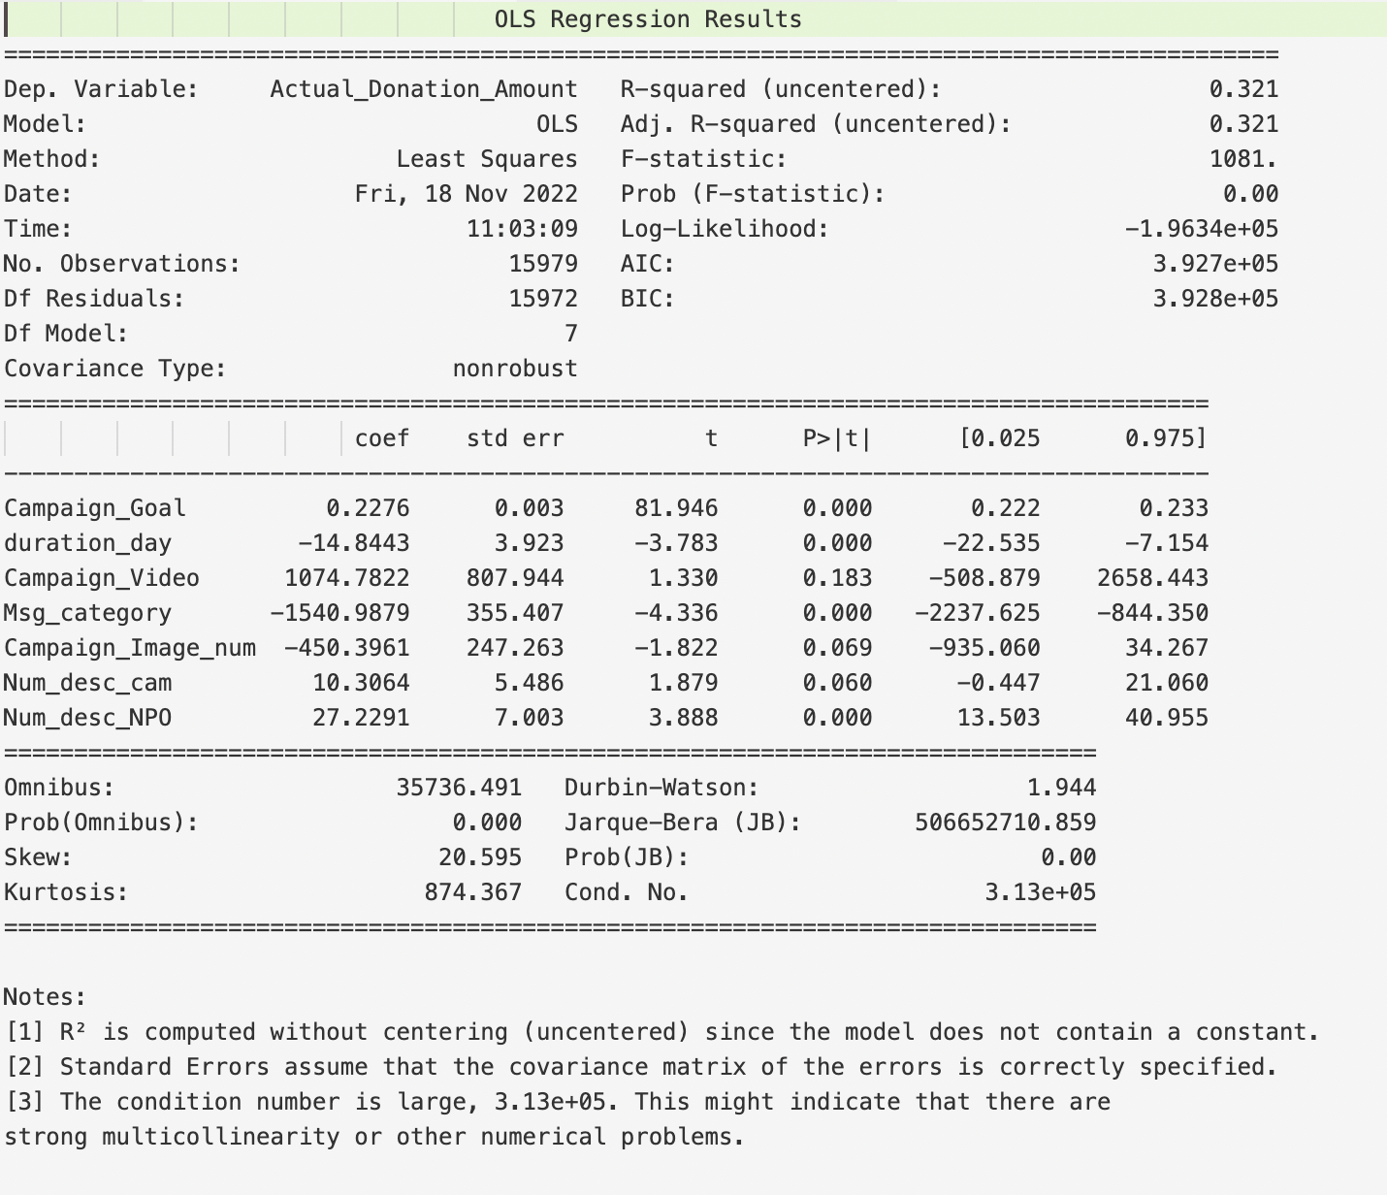

Use the new message category, the S square doesn’t change

Actual_Donation_Amount = Campaign_Goal + duration_day + new_msg_category

+ Campaign_Image_num + Campaign_Video + Num_desc_cam + Num_desc_NPO

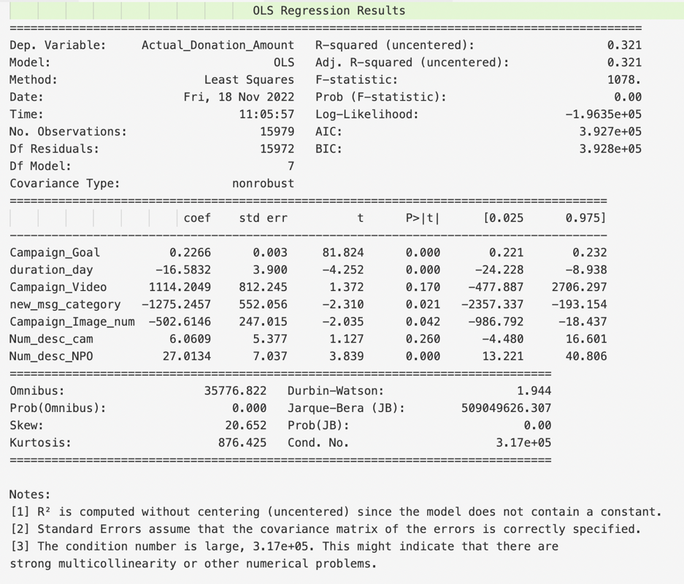

Model 3 The regression result

I remove Campaign_Goal from independent variables the coef change a lot. Some negative coef become positive. So I think this can prove the words said above.

Actual_Donation_Amount = duration_day + new_msg_category

+ Campaign_Image_num + Campaign_Video + Num_desc_cam + Num_desc_NPO

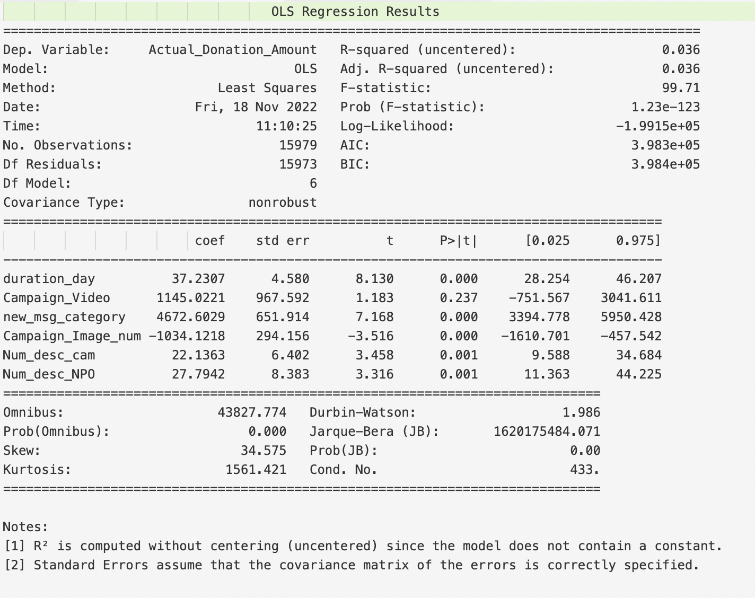

Model

Actual_Donation_Amount = Campaign_Goal + duration_day + new_msg_category + NPO_Tax_Deductibility + Campaign_Image_num + Campaign_Video + Num_desc_cam + Num_desc_NPO